DOI: 10.34658/xxxxxxxxx

TITLE OF YOUR ARTICLE

Author Name^{1(*)}, Author Name², Author Name³, Author Name^{1,2},
¹ Institution 1, Address, City, Country ORCID
² Institution 2, Address, City, Country ORCID
³ Institution 3, Address, City, Country ORCID

^{(*)} Email: email@email.com

ABSTRACT
Authors of oral presentations or posters are requested to submit an article (4 pages) in English. The article must include the title, author(s), abstract, material and methods, results and discussion, conclusion and references. The manuscript should be prepared on an A4-sized paper with 25 mm margins on all sides and typed with single spacing using size 11 Times New Roman font. The abstract should be a total of about 200 words maximum.

KEYWORDS
Three to six pertinent keywords need to be added after the abstract. We recommend that the keywords are specific to the article, yet reasonably common within the subject discipline.

INTRODUCTION
The introduction should briefly place the study in a broad context and highlight why it is important. It should define the purpose of the work and its significance. The current state of the research field should be carefully reviewed and key publications cited. Please highlight controversial and diverging hypotheses when necessary. Finally, briefly mention the main aim of the work and highlight the principal conclusions. As far as possible, please keep the introduction comprehensible to scientists outside your particular field of research. References should be numbered in order of appearance and indicated by a numeral or numerals in square brackets—e.g., [1] or [2,3], or [4–6]. See the end of the document for further details on references.

MATERIALS AND METHODS

The methodology must be clearly stated and described in sufficient detail or with sufficient references.

RESULTS AND DISCUSSION
The findings and arguments of the work should be explicitly described and illustrated. All the tables, images and figures should be centered. Figures and images should be numbered and figure headers should be placed under the figure or image; as for the tables, they should also be numbered and the table header should be placed at the top. References (if any) of the tables, figures and images should be presented right under the tables, figures and images in the form of author surname and publication date.

Equations
Equations should be centered and numbered consecutively, as in Eq. [1].

(1-line spacing here)
[1]
(1-line spacing here)
where,

Tables and figures
Tables and figures should appear in one column of a page and be numbered consecutively. Figures and texts may appear on the same page, and a centered caption should appear directly beneath the figure. It is preferable that figures be mounted in portrait style and figure captions are no longer than two lines. On figures showing graphs, both axes must be clearly labeled (including units if applicable).

Tables should be designed to have a uniform style throughout the paper, following the style shown in Table 1. Table captions should be in 10pt “Time News Roman” bold, centered, and the texts in Table should be set in 9pt “Time News Roman” font.

Table 1. Caption heading for a table should be placed at the top of the table and within table width.
(Use “time news roman” font, size 10pt, No spacing after table title)
 | A | B | C | D
A | Aa | Ab | Ac | Ad
B | Ba | Bb | Bc | Bd
C | Ca | Cb | Cc | Cd
D | Da | Db | Dc | Dd
E | Ea | Eb | Ec | Ed
Source: [1,2]. (Times New Roman, 9 pt, left justified)

Authors are advised to prepare their figures in either black and white or color. Please prepare the figures in high resolution (300 dpi) for half-tone illustrations or images. Figures must be originals, computer-generated or drafted, and placed within the text area where they are discussed. Figure 1 shows one example. Figure captions should be in 10pt “Time News Roman” font, bold, centered. When applicable, the texts in graphs, illustrations or images should be set in 8pt “Time News Roman” font.

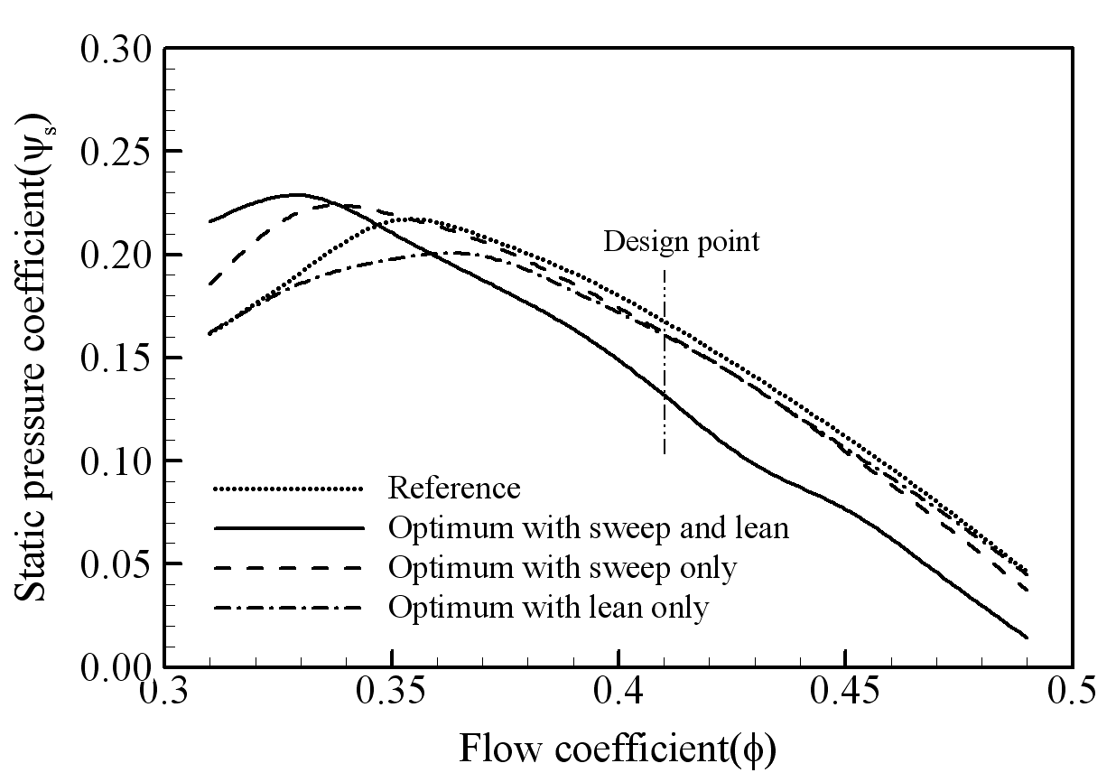
Figure 1. The caption heading for a figure should be placed below the figure and within figure/illustration width. (Use “Time News Roman” font, size 10pt, no spacing between title and figure)

Source: own calculations based on [3]. (Times New Roman, 9)

CONCLUSION
Conclusions should include the principles and generalisations inferred from the results, any exceptions to, or problems with these principles and generalisations, theoretical and/or practical implications of the work, and conclusions drawn and recommendations.

ACKNOWLEDGMENT
The authors would like to express appreciation for the support of the sponsors [Project Number = XXXXXXX].

REFERENCES
References should be listed inside square brackets in the text with numbers should be listed according to their order in the text using the APA style. Example:

[1] Yemni, T., & Boyd, R. H. (1979). Dielectric relaxation in the odd‐numbered polyamides: Nylon 7‐7 and nylon 11. Journal of Polymer Science: Polymer Physics Edition, 17(5), 741-751.

The author must check all the articles that are included in the bibliography of the submitted paper whether the articles cited have DOI numbers.

